EXERCISE 2.2

**NCERT Solutions for Class 10 Chapter 2-**

**Polynomials**

EXAMBUDDY

Question 1:

Find the zeroes of the following quadratic polynomials and verify the relationship between the zeroes and the coefficients.

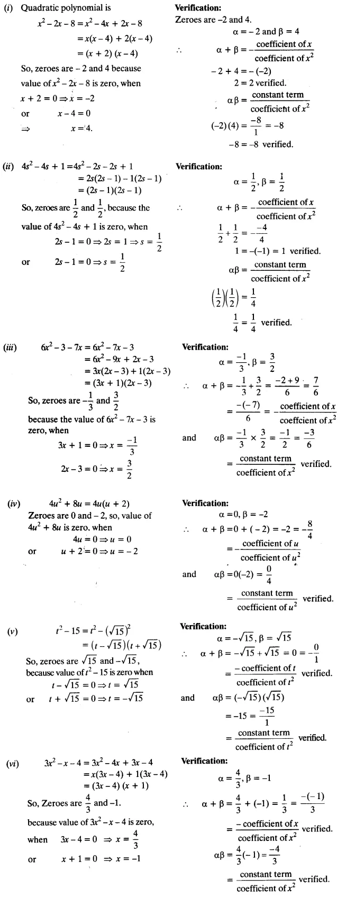(i) x2 – 2x – 8

(ii) 4s2 – 4s + 1

(iii) 6x2 – 3 – 7x  
(iv) 4u2 + 8u  
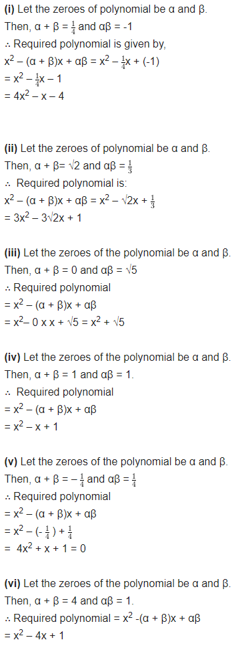(v) t2 – 15  
(vi) 3x2 – x – 4

**NCERT Solutions for Class 10 Chapter 2-**

**Polynomials**

EXAMBUDDY

Question 2:

Find a quadratic polynomial each with the given numbers as the sum and product of zeroes respectively:

**(i) 1/4, - 1**

**(ii) √2, 1/3**

** (iii) 0, √5**

**(iv) 1, 1**

**(v) - 1/4, 1/4  
(vi) 4, 1**

**NCERT Solutions for Class 10 Chapter 2-**

**Polynomials**

EXAMBUDDY